Matt Smart www.MattSmart.org @mattsmartart
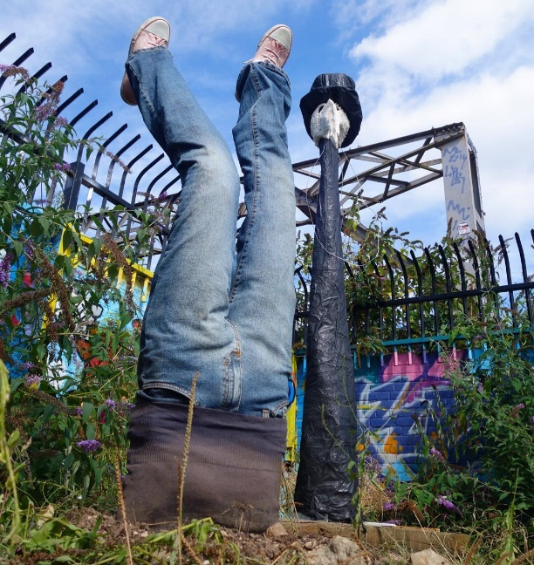
Many Happy Returns

Whatever you do, love it. Throw yourself into your passions.
Many Happy Returns reflects the circularity of the earth and our place in it. We are of the earth, and we return to it. Embrace your leap and dive. Make the most of everything.

The figure looks as if he or she has fallen from a great height, and plummeted into the soil comically, by surprise. The clothes and boots are worn, reflecting a life lived. Many Happy Returns celebrates how the earth is to be respected. It is you and me. Dive in!

Ghost

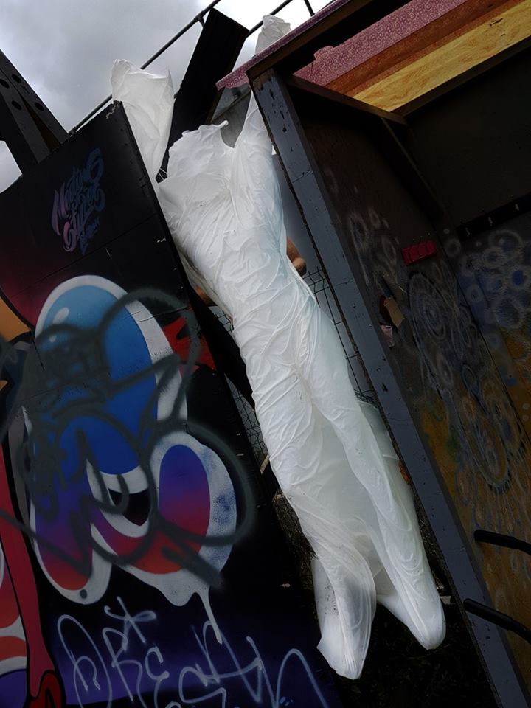
Strong and lifesize, she weighs just 1½ kilograms (about 3lbs). ‘Ghost’ began as an experiment in materials. I felt that cloth could replace glass fibres as a reinforcement for resins, and that such material could stand unaided. I wanted a sculptural challenge, and realised what could be done with gravity, drape and movement. The fabrication is considerably more complicated than it may appear. While materially simple, ‘Ghost’ is one of the most involved in its construction, and its underlying concepts.

The sculpture is about whatever you want it to be. To me it has several notions. It is a literal reflection of the impressions people leave, particularly in our memories. It is about hoe “ghosts” can be what persists in our hearts, whether or not the people who haunt us are still living on earth. It also alludes to the impressions that we leave in our surroundings – the ideas we spread, footprints, our use of materials (with the wordplay on the sculpture being made of material).
The impressions we make on the world through our drives and efforts can feel insubstantial, as echoed by ‘Ghost’’s near weightlessness. Beauty of action, like sculpture, does not have to depend upon solidity or gravitas.
Around these concepts, ‘Ghost’ shows a shrouded woman. Women are underrepresented in history. This issue is well represented by a project called “Women and the Canon”. Think of the names of the greatest composers, painters, scientists… they are nearly all men. Women are hidden from the canon of what is considered exemplary. For instance, the most influential art work of the 20th Century, ‘Fountain’ credited to Marcel Duchamp, was created by Elsa von Freytag-Loringhoven (“Who is she?”, you ask. “Exactly”.) So many women’s endeavours are hidden, while the existing canon of Picasso, Mozart…etc. is still taught in documentaries and in schools. The female figure is portrayed in art - as it is in this sculpture, in veiled form - while women’s creative and intellectual contributions are shrouded. ‘Ghost’ is the contributions women have made, that are unseen, passed away, and silenced. They live on for those who believe, remember, and see them.
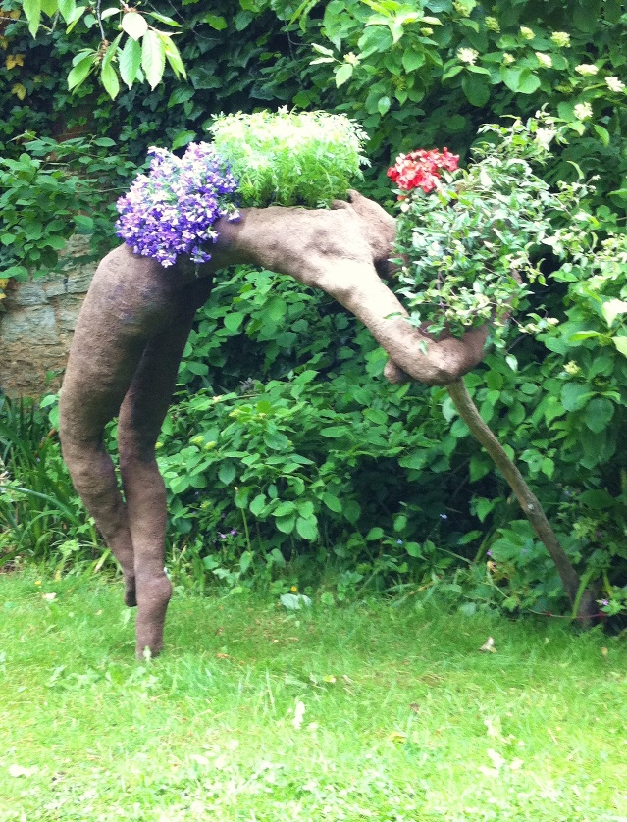
Breathe

I wanted to lighten my works, in the sense of making them more light-hearted. As light as air. As breath.
Drawing from breathing and physical exercises, and the gift of clean air from plants, ‘Breathe’ depicts a figure being lifted by the parts through which we breathe: our face, lungs and diaphragm. Plants lift our spirit, and our body.
‘Breathe’’s structure hints at new architecture techniques which include planting spaces as part of multi-level buildings, in ways that actually increase the amount of green space per square metre of land. In this case she adds about 35% of earth and planting space in the space she occupies, which is about the same proportion as the best modern architecture achieves.
You can grow flowers in ‘Breathe’, and get extra planting space.
‘Breathe’ shows us as being part of the garden, between earth and air. Lifted, and in balance.

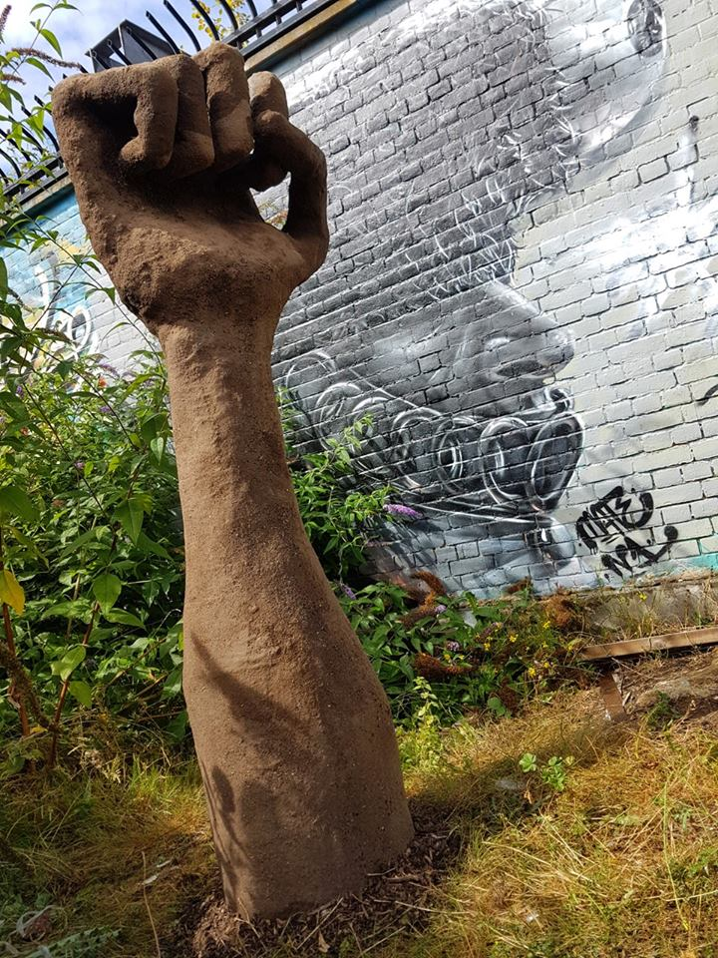
Earth Fist
(“Growth”)

The Fist is about our collective ability to make change. It reflects all collective issues, the most overt being responsible land use.
It is about the word “Growth”, which used to mean the growth of the soil: crops, gardens and forests. Now it means economic growth. Yet economic growth is still based on land: the common reliance on property investments to solve what are fundamentally economic issues such as pension plans or investments for children’s future education. Yet soil does not deliver those things. The word “growth” is being stolen from us. The Fist is about resistance.
Beneath, and gently, the sculpture is also about public and media perceptions of energy companies. It represents the combined strength of the people and of corporations, rather than posing them in conflict. I have worked with heads of the UK offices of some oil and gas companies, and then with some of their teams, on environmental sustainability and economics. They are onside. My experience is that the executives do far more for sustainability than shareholders, or than most consumers do. We can solve sustainability better if we stop treating energy companies as enemies. In any passionate dispute there is common ground to be found, as a basis for shared strength and progress. We also have strength to resist if we feel that we or the land are being over exploited. That is the Fist.

(Grand Prize Winner, ‘Change The World’ art competition, Oxford Town Hall, Poseytude Gallery, May 2016)

Matt Smart www.MattSmart.org @mattsmartart

Matt Smart www.MattSmart.org @mattsmartart

Cherokee Chairs
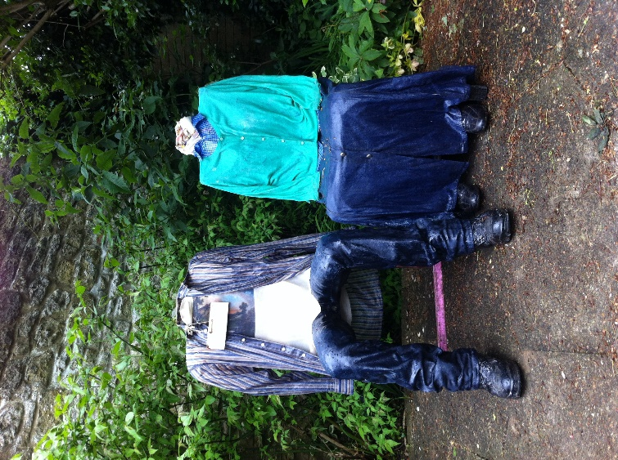
Cherokee Chairs are public or private seating that looks like people. The seats are fully useable, robust and waterproof. The design is inspired by American settlers.

The work references the American Dawes Act of the assimilation of native North Americans. Senator Dawes’ main reason to instigate his Indian Allotment Act was Chief Standing Bear, a Ponca Indian of the Lakotas, who walked 600 miles though winter to bury his son after being forcibly removed from his tribe’s native territory and burial site. Tribal land was removed from tribal governance and allocated into immediate family ownerships, and to single males – small allotments, effectively removing collectivised responsibility and management of the land and nature.
“Assimilation” through the Dawes Act was the condition for any native inhabitants to have any rights to any land and resources at all. This required western schooling and church attendance, and replaced tribes’ animal and earth spirits with the imperative to go forth and multiply, with divine dominion over bird and beast. The Indians had to accept these conditions in order to be accepted people. Without it, they were beasts, not people, with no rights to land use. Chief Standing Bear’s contention to rights to bury his son in the tribe’s sacred ground was “I am a man”, a view which was eventually accepted because he wore western clothes and went to church, and asked to be taught how to farm land the western way.
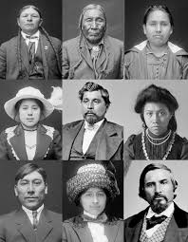
After the Act was effected Standing Bear could have been renamed ‘Sitting Clothed’: a westernised sitting tenant in the required Euro-American attire. The chairs are dressed in keeping with the spirit of those traditional clothing customs at the time.
We can sit on these chairs in recognition of this heritage’s fundamental support for our current condition, just as we may “stand on the shoulders of giants”. The frozen nature of the hermetic sealing of the chair people reflects the sealing of free people into a restrictive and immobilising law and way of life.
The Cherokee are a native North American tribe.
“Cherokee” means “the real people”.

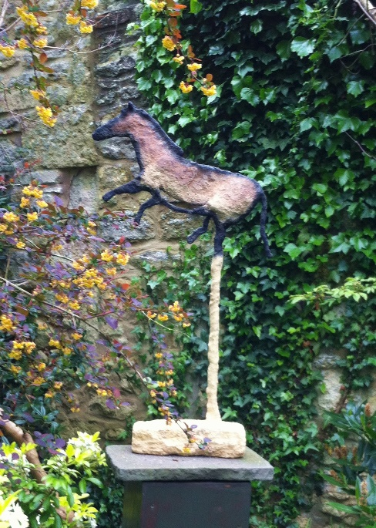
Muffin of Lascaux

‘Muffin’ is a sculptural rendition of cave paintings of horses as seen in the ancient human inhabited and visited cave complexes discovered in the past hundred years or so, such as Lascaux cave in southern France. The sculpture uses earth minerals in keeping with the original pigments, sourced from nature by the artist.
In modern terms it is in keeping with the tradition of equine art and sculpture.
Cave art has many parallels with street art, including the rendering of 2D art, with drawn outlines, onto 3D surface, just as wall art inhabits 3D urban space. Street sculpture inhabits land space, whereas wall-based street art works only on a city’s delimitations (walls being equivalent to the lines in a drawing, when we consider an urban space from above, in an architectural-plan view). While highly unobvious, this work is subtly about the differences between street art’s wall art and street installations in terms of occupying spaces, as well as expressive freedom.
Cave art is the origin of written communication, through heiroglyphs Cave art is brilliant.
Matt Smart www.MattSmart.org @mattsmartart

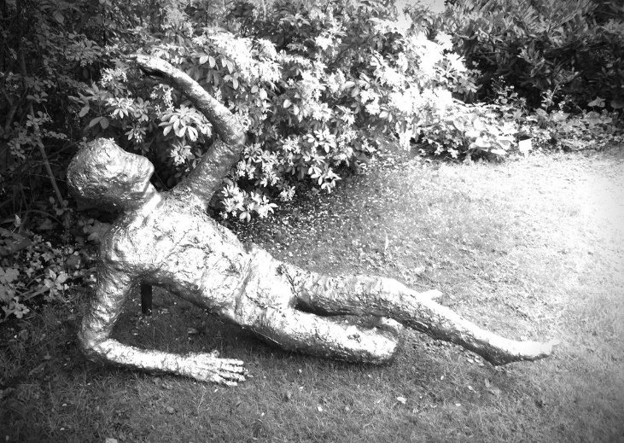
Seizar (Selfiezar)

'Seizar' celebrates desire and the ability of the land to provide Glory and wealth, and to suspend them.
Pompeii was sealed in volcanic ash. People excavated from Pompeii are mostly reclining or lying, with hollow eyes and with a sealing ash layer that simplifies and distorts their features.
The sculpted figure is coated with bioresin, a natural-based alternative to traditional casting resins: sealed and preserved with a natural coating, as are mummified remains from natural disasters.
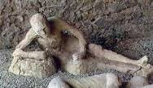
The overall sculpture plays with treasure's actual and mythical relationships with natural bounty and phenomena, and the notion of “seizing”. The gold leaves are real leaves, whereas ‘real gold leaf’ is made of gold but not of leaves, separating wealth from environmental processes which provide resources and make their appreciation possible. The figure has a light dusting of calcium carbonate-rich ash-like soil, sourced from an abandoned stone quarry which has now reverted almost entirely to vegetation.
Pompeiian times are still considered to be among humanity’s heights (or depths) of indulgent behaviour, and even then Pompeii was considered to be exceptionally indulgent. When Vesuvius covered Pompeii in ash it was quite widely thought of as an act of gods’ judgement for excessive vanity. ‘Seizar’ is taking a selfie.

MattSmart.org 07500 118791 matt.smart@mail.com

Matt Smart www.MattSmart.org @mattsmartart

We Met One Day

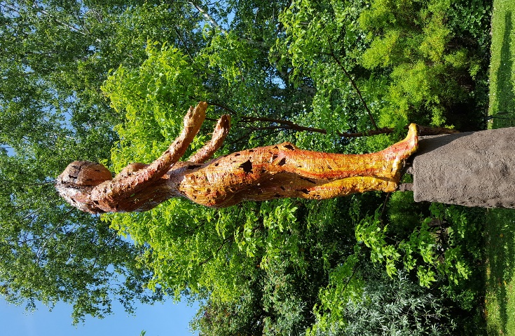
Courage, surfaces, evolving an ideal, growing and changing, and getting to know someone…

Talk to them.
Talk to that person who impresses you as you look at them from afar, and wonder about them. Seize the courage to introduce yourself. How many times have you seen someone amazing and been afraid to talk to them?
How many times have you found that they felt the same way?
Our Achievements and appearances make us noticeable. But it is our flaws and frailty that make us loveable. Impressive people are intimidating. We put them on tall pedestals, incomplete. The person inside the shell is obscured. We miss their inner beauty, just as we hide our own. We make Gods and Goddesses, raised high with proud posture… The figure seems pitched as if ready to dive, or to help pull us up. Just as we can wonder whether a person we admire - of whom we have made a mental statue - will dive in and talk to us, and help us reach the level we see them on, and desire. Is that a vision of the courage we seek in ourselves? The question is really… will you?

The figure alludes to Eris, Goddess of Chaos and Discordia: doing things without knowing the outcome. Indeed much of the concepts were different when ‘We Met One Day’ began. The initial intention was to create an evolutionary series of the ascent of woman, for equality emphasis, because all drawings of the evolution that we see, from hominid to homo sapiens, show images of males. There should be evolutionary diagrams that portray women, and the concept of this figure was as a slightly futuristic woman, but in which the humanity is obscured to reflect how humans are moving into synthetics and automation. But, as with Discordia, (and as with getting to know real people) other meanings emerged and evolved. Many relationships start like that, be they great friendships or love.
We all change. I love people and sculpture for their life: how they change and grow, and have new meanings to cherish. We can love sculpture in a fixed way, and want to keep it like that forever. The unchanging immoveable solidity of bronze and stone, which can look realistic, but never looks real.
I do not love people or sculpture in that way. I sculpt in light materials, and display them temporarily, to give them freedom. Hence the option to hire sculptures, and get to know them, rather than buy them ostensibly forever without change.
We do not know whether a relationship will blossom. We may end up saying or singing “We met one day, when ….” about a close friend or loved one. The point is that you met at all. We will only ever say that if we take courage to talk to that mysterious, amazing wonderful god or goddess we put on a pedestal. Then get to know them.
Love sculpture for its versatility, changing meanings …its life. Be with it, and keep it with you, if there is connection. Be with a sculpture for as long as it talks to you. That may be forever.

