IF FOUND, RECORD THE TIME AND LOCATION, AND DELIVER THIS ITEM IMMEDIATELY TO THE NEAREST CARE AGENT OR CARE UNIT

Instructions

User manual and safety Protocol

Physical material type: 1-4964-71037-20177643-KR-1.2

Bi-surfacial One-directional Organic Kryptograph

Vern.: “Block Of Old Knowledge”

“BOOK”

SAFETY INSTRUCTIONS

- Do not deviate from the age range and Care Level stated on the BOOK.
- If you become aware of any citizen deviating from the age range and Care Level of a BOOK, or part thereof, Report immediately to your designated Care Unit or to the nearest Care Agent.
- If you become aware of any citizen encouraging or facilitating deviation, Report immediately to your designated Care Unit or to the nearest Care Agent.
- Do not exceed the recommended daily amount.
- Do not use a BOOK while operating machinery.
- If ordered or advised to discontinue operating a BOOK, do so immediately.
- If operating a BOOK for longer than 20 minutes, Report to your designated Care Unit within 20 hours.
- Do not operate more than one BOOK during a 25 hour period without prior Authorisation.
- Follow the specified direction of the BOOK.
- Avoid connecting one part or sub-unit of a BOOK with another part, or with parts or sub-units of other BOOKs, without prior Authorisation. If this does occur seek immediate Care Unit advice.
- Always adhere to the prescribed medication or Care regime before and after operating a BOOK.
- Do not connect a BOOK to a charging device/outlet or any other form of power or communication source.

Enjoy your BOOK.

DIAGRAM
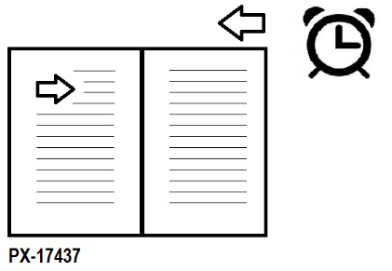
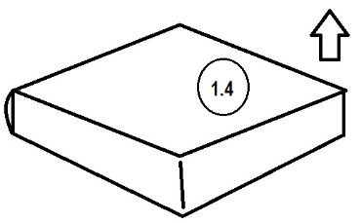

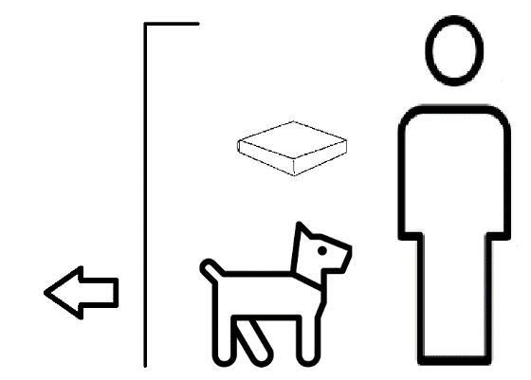

SPECIFICATION

The BOOK is self-maintaining.

Storage units are supplied separately.

Every BOOK is supplied pre-named. It is illegal to give a name to a BOOK. If you see a BOOK without a name, do not touch it, but Report immediately to your designated Care Unit or to the nearest Care Agent.

A BOOK is a collection or series of double-sided flat surfaces connected along one edge, with an outer coating to the exposed surfaces and the connective edge. The sheets are made of organic-based materials.

PRE-OPERATIONAL REQUIREMENTS
Complete accredited course RX-1973-2-42106-54.221005.
Complete the accredited course numbers stated in the Care Directorate for the designated BOOK.
Register the prescribed medication or Care regime.
Complete License Protocol NQ-1008-1-22315-16.1520.
Run Protocol CX-4047-1-27404-968.32.80006.470002 ‘Mind backup’ Protocol.

INSTRUCTIONS FOR SAFE USE
- Remove pets, other humans, and class 7 insects. Close window. Ensure temperature between 241K and 504K.
- Ensure ventilation.
- Uninstall protective wrap.
- Place protective wrap in wrap protection sachet. Seal sachet, ensuring full seal.
- Place the BOOK on a flat surface.
- Sit or stand facing the BOOK, with your eyes approximately 1 to 3 cubits from the BOOK.
- Ensure that the lighting is at level 2 or above, but does not exceed level 9.
- Initiate timer.
- Follow instructions.
- Open BOOK (see Diagram, refer 1.4). Once BOOK is opened in accordance with specified optimal angle range, stop opening BOOK.
- Verify compatible Language Protocol (Inst. KR-1096-3-37099-41.7724.3). If incompatible, cease, unopen BOOK, unseal sachet, reinstall protective wrap.
- Open frontal cortex.
- Form sounds in frontal cortex. Connect limbic system, starting at Level 1.
- When all symbols in the specified direction have been processed, proceed to next symbol group and reconnect with symbols.
- Repeat.
- Ensure continuation process between the surfaces is followed as directed. When symbols on both surfaces have been processed, articulate Organic surface in accordance with direction guidance.
- Proceed linguistic process in specified direction at safe speed.
- Reconnect with symbols.
- Assess for indigestion, sleeplessness, agitation, nausea, and vomiting, skin pallor, atrophy, bone disorders, skin sores. In event of any Contrindication, cease, unopen BOOK, unseal sachet, reinstall protective wrap. Report immediately to your designated Care Unit or to the nearest Care Agent.
- In absence of Contrindication, enhance connection to limbic system. Do not exceed Level 4.
- Nod head at intervals to enhance the BOOK experience.
- When timer sounds cease, unopen BOOK, unseal sachet and reinstall protective wrap.
- Repeat according to Schedule Protocol SX-4949-2-77103-623.
- When all symbols on all surfaces have been processed, cease, unopen BOOK, unseal sachet, reinstall protective wrap. Report to your designated Care Unit within 20 hours.

CONTRINDICATIONS
May cause indigestion, sleeplessness, agitation, nausea, and vomiting.
May cause exaggerated central nervous organic operational activity.
May lead to awareness.
May affect your unborn child.
May lead to antisocial tendencies.
May result in death.
May lead to addiction or unusual cravings.
May cause skin pallor, atrophy, bone disorders, skin sores.
May cause sight defects or blindness.
May result in elation.

Enjoy our BOOK.

Sculptures by
www.MattSmart.org

