Hey, sorry I’ve taken a while to get back to you. It’s been a bit weird here too, but maybe not as much.
I’m used to you being near the rooftop every eight months or so, but this time seemed different. So glad you’re back.

There was something I wanted to suggest, or offer, back then. And then, when you posted about people not understanding that depression is made of many parts, I worried that I had upset you by mentioning it but not telling it well. Then I re-read what I’d written to you, and realised I hadn’t mentioned depression at all ! I had wanted to, but it felt too raw and delicate back then, so I deleted it and didn’t say it. You posting about the many parts of depression was coincidence or something.
What I wanted to say back then was very similar to that image of how depression is made of many parts.

I’ve never been far down, but once I got close to big depression and disfunction.
It lasted a few months. I could feel it breathing down my neck, and knew I had to struggle against it and fight it. I figured I had to do everything I could to beat it. Like if you ever get in a physical fight, you might think it’s enough to fight back a bit, and just do what you think will be enough to stop the other person attacking, or to beat them. Do just enough.
But “enough” is not enough.
Cos if the attacker is stronger than you think, you’re beaten.

So, that time when I was struggling with parts of depression, I figured that to get past depression I must fight it with everything I could, every tactic I could think of.
I used loads of ways. None of them are particularly new or clever.

I used Music as a mood adjuster, to tune my moods. I downloaded lots of cheerful music, new music, and played that instead of the old stuff that kept me where I was… and the new happy music made a difference.

Also I talked more with a couple of trusted friends who know me well, and made sure I kept in touch, so that they would tell me if they thought something was going down.
Made sure I showered, kept clean, shaved, paid attention to my appearance, cos your face is a mirror, and if you look sad it reflects back and people sneer at you, which makes you feel worse, and then you might never see anyone finding you appealing or pleasant or desirable or potentially good company. So I made sure I didn’t look ill. I made myself look well.

I went to the GP and spoke about my situation and depression. Didn’t get meds.
Comedy too – listening to thoughtful comedy was important for me, helping to accept that the world is ridiculously awful, or awfully ridiculous.

I got myself referred to a counsellor. She did not help much, as far as I could tell – maybe not at all – but she did say “it seems like you are doing everything possible.”

I made sure I danced and sang sometimes.
Made myself start to put plans in place for events later in the year, and other hopeful things in summer and autumn to look forward to, to give me some focus, and clung onto them as hope for happiness.
I watched what I ate. Cut my hair tidier. Sometimes wore clothes with less holes in. Made myself do exercise, thinking “if you don’t do this you’ll slip, and you may end up on the streets alone and never get back, you’ll never make anything beautiful again or have friends you love. So do another 50 crunches. You have to. Yes. Keep on going.”

I wrote a list of things I have done that I had once been proud of, or happy about, and then i rationally contextualised whether they really were special or good or impressive, or whether I’m just an arrogant pathetic pretender and a waste of space – and it seemed objectively that quite a lot has genuinely been a bit unusual, and might justify me and others feeling that some things I have done are maybe pretty cool and brave. And if I’d done such things in the past, I might be able to do good things again. That history was an occasional reference point, and a way of challenging myself to say “yes, you mean something” – to battle the self-loathing, and to help against guilt and hopelessness.
Also I consciously forced myself to smile, particularly in public, and was aware of people’s reactions, and it did help more smiles grow…

None of that is amazing. You probably know and use all these methods. I’m not trying to teach you anything with this waffle! It is just that, from where you seemed to be, back then, a handful of weeks ago, it felt like you were having most trouble with the ‘Nothing’ part of depression in ways illustrated by that picture of the colours and parts of depression. Mainly where you were felt like the “Nothing” part. Also self-loathing, and some guilt. And some anxiety. (Those are the bits that attacked me most, so maybe I just keep on projecting!) And sadness. All of it. And I wanted to talk with you or say something about the “Nothing” part.

For me, a big way to beat ‘Nothing’ was through friends: their contact, and feeling worth enough to merit any care from them. But when you feel like that, you don’t dare try to call them, because you feel like you are a burden, or deluded, or a terrible person, and it is scary to ask someone anything, or even lift your eyes to them. To get to those friends I had to get past self-loathing, anxiety and guilt. I figured the ‘Nothing’ I felt might be battled with friends (and also a bit by music, and by being smiled at, and by having things to look forward to – they all helped me against Nothing). But to get to friends I’d have to get past self-loathing and anxiety. And they’re very tough.
For anxiety, I started doing things on impulse. Acting on impulse. You know the 5-second Rule? Not the version about dropping food on the floor. The one about acting on impulse before the impulse goes away: if you feel like doing something, but you lack motivation or energy or conviction or courage, then if you don’t do that thing within 5 seconds, you won’t do it at all. And then you’ll feel worse. So you have to do it within 4 seconds, to get it done, and feel better. So you must just do the thing. What have you got to lose? That’s how I reasoned it. So I started practicing acting on impulse - which at least made life a bit more interesting. And it meant that, in the moments when self-loathing was low, and I felt that I might be worth helping, I was then able to act on the desire to contact friends, get past the anxiety, and their acknowledgement of my existence would help me fight ‘Nothing’. That’s how I managed to keep in touch with people who would tell me if they were worried, and might intervene. And they’d also make me feel something – feel more than empty nothing.

Anyway, dear distant friend S, for me all those parts of depression are tough, some harder than others, but they don’t all work together, or at the same time. I guess I devised ways for my various techniques to work together, while the parts of depression did not work together. I could separate the parts and slowly beat them, and grow more confident.
Anyway, that’s how I got past Anxiety and self-loathing to fight the big Nothing.

But back then, when I wanted to see if any of this could be a way to support you, you were hit really hard by so much of it – with guilt and self-loathing, that I was afraid to say any of this. Cos just mentioning it could have intruded and made you feel worse. So back then I was just going to carefully mention that I feel for you, and that I have struggled with depression a bit too. But no-one really has the same depression or situations, so if I had mentioned it, it could have come across as condescending, or assuming I have a clue how you can feel. Cos depression is not just sadness, and often when people try to help, we can feel that they do not understand or know the parts of our struggle and pain.
And then you posted that picture about the many aspects of depression, and I thought “oh no, did I upset S---- by mentioning depression? I must have sounded like I was giving advice about depression, without having a clue how she is feeling. That’s so terrible! She mustn’t be hurt!” Cos I had considered really carefully how to write something positive to you, without intruding into your tiny remaining bit of safe space ; so when I was writing to you something short and hopefully encouraging, I had agonised about whether to mention that I might be able to empathise a bit about depression.
But then I couldn’t remember what I had actually written to you that could have upset you. And I really wanted to sort out whatever I had said, so I got the courage to re-read what I had written to you, …and I realised I hadn’t mentioned depression at all! You posting about depression soon afterwards was a coincidence, or synchronicity or something. (Or maybe just by thinking about it i had caused some kind of upset across the cosmic threads. Yeh, that guilt thing, eh?! It gets everywhere! Yup, I often get that guilt part.)

That graphic picture of the many parts of depression is quite true of how it affected me. It’s kind of perfect proportions. I hope you find it useful.

Anyway, I just wanted to say that I was wondering if you also had trouble with ‘Nothing’, and if you did, maybe my experience of tackling Nothing, and fight depression bit by bit, could be relevant, and maybe help you if you need to get past anxiety and self-loathing, to then be able to confront Nothing.
Sorry if any of this sounds preachy! It’s been a weird couple of weeks, hasn’t it.

I really really really hope you’re doing well. You don’t need to feel embarrassed of guilty or a fraud when so many people get in touch and say how special you are. Just let it be true. At least a bit!
I’m good. There’s often a bit of darkness in here, but it rarely grows much. Feeling well.

Much love.

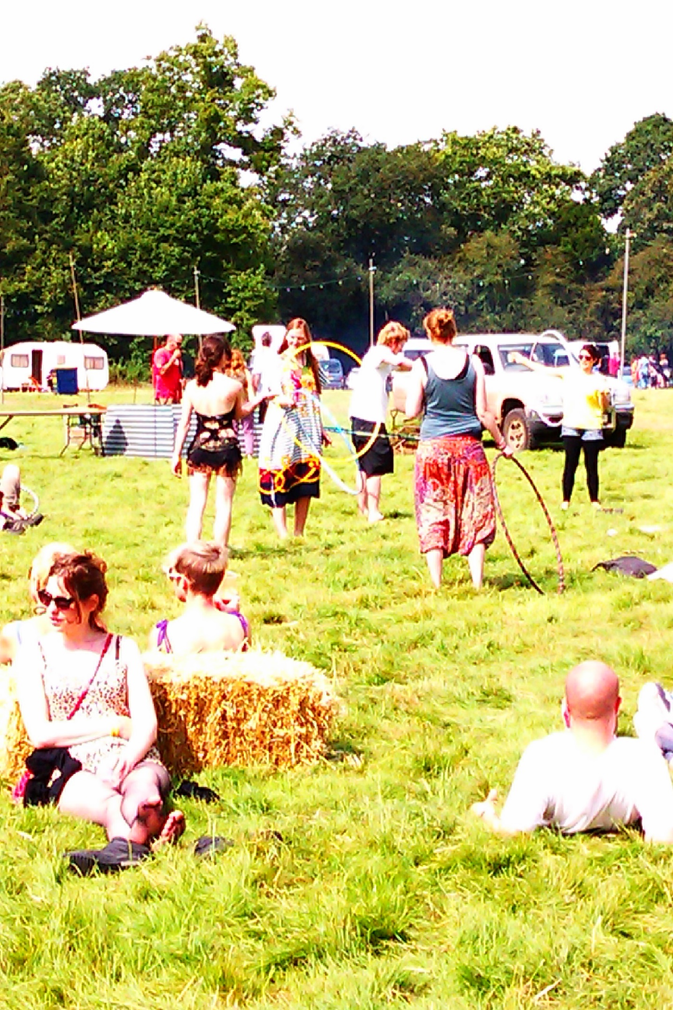
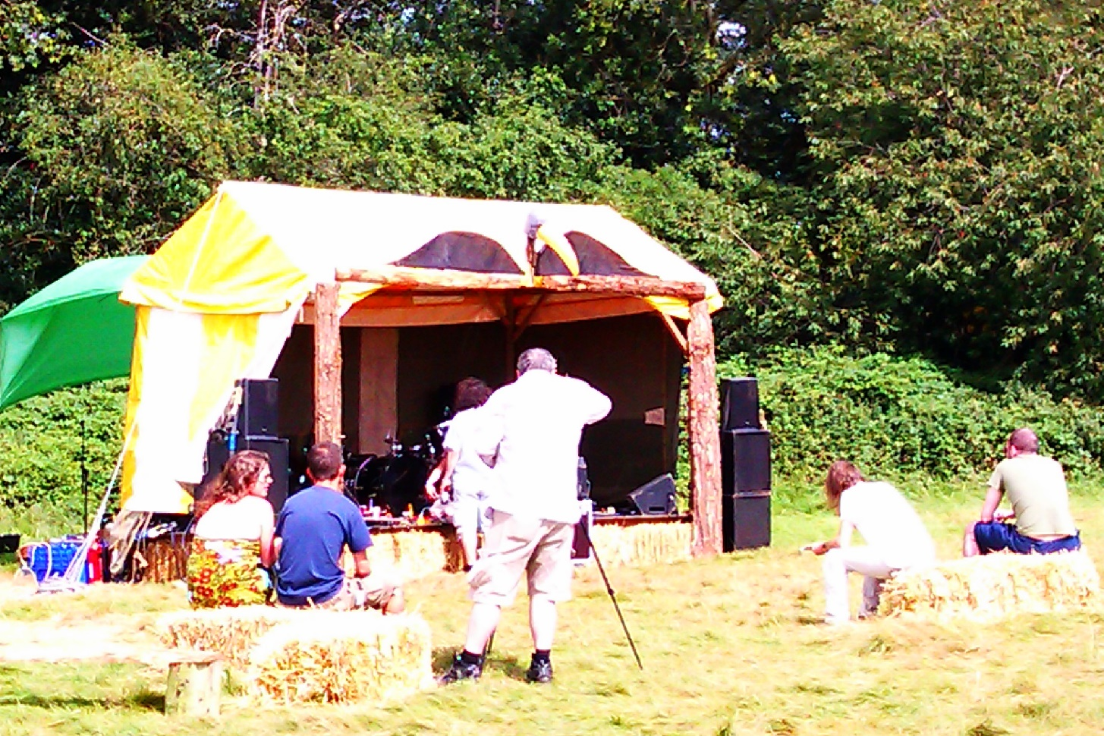

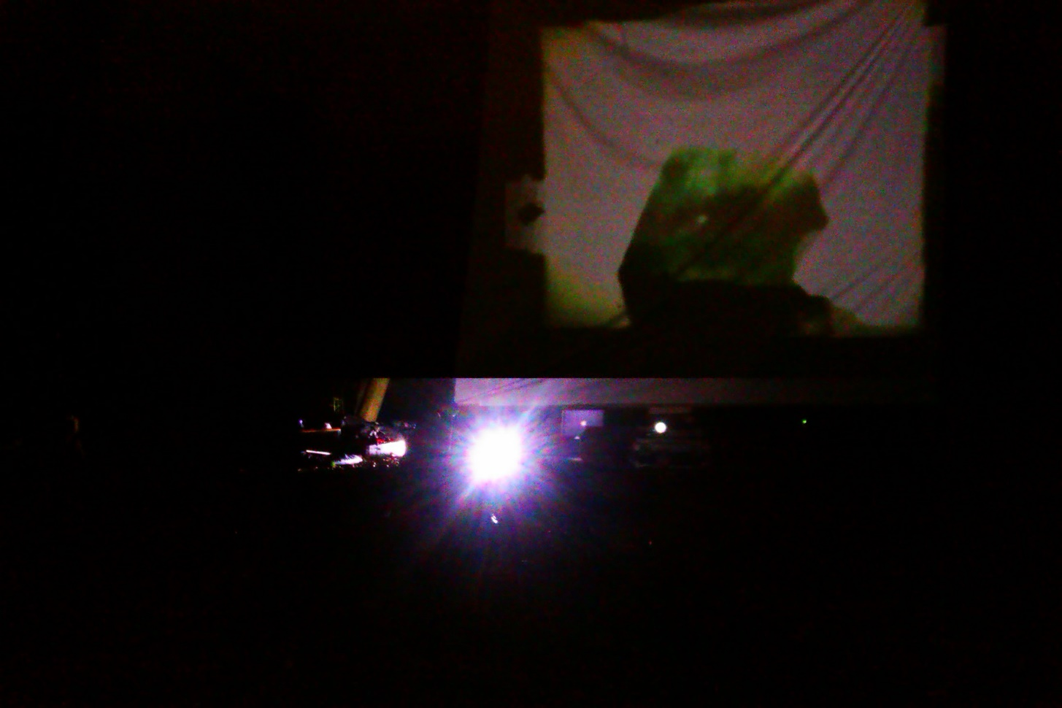

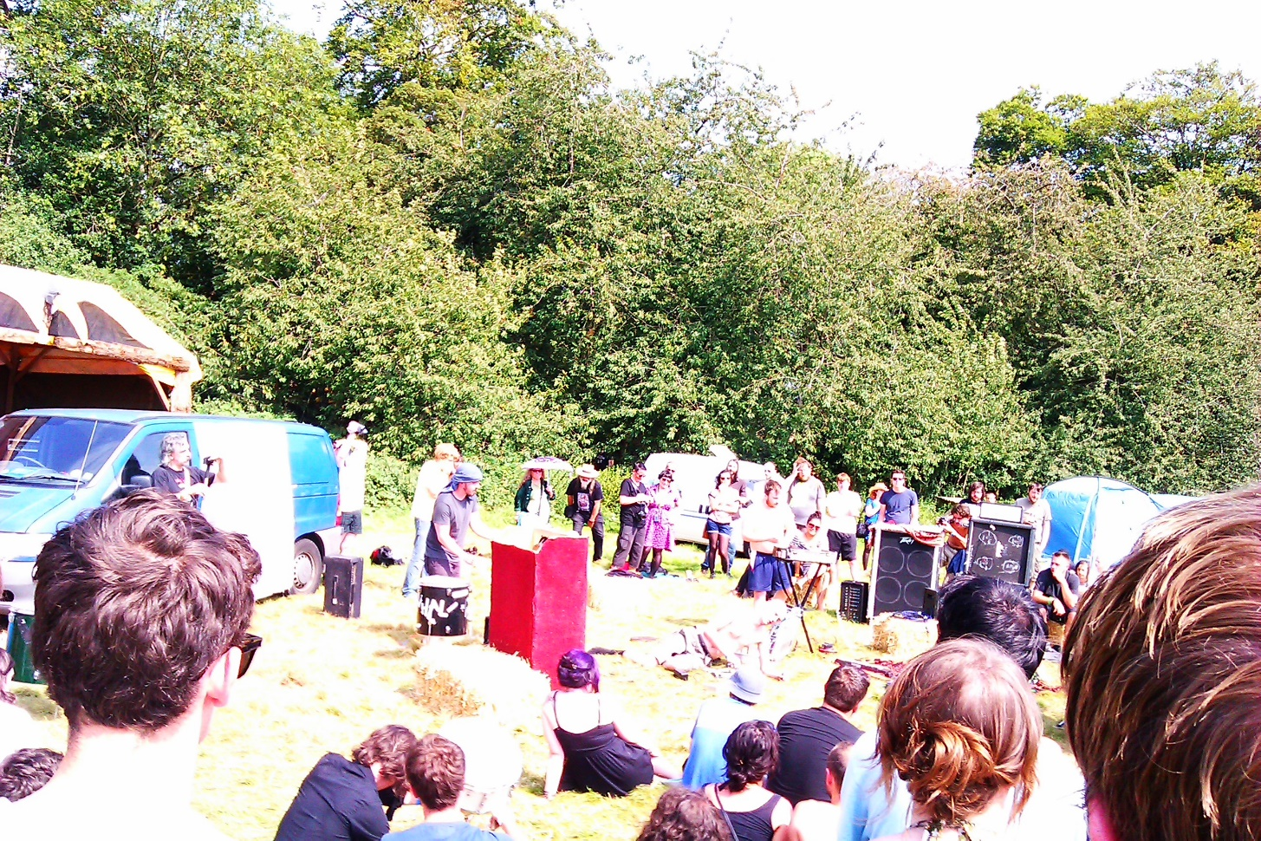

Supernormal 2012 was when I started doing sculptures. That fest was very formative. I cherish it. You really helped me there, though you probably don’t know it at all. Helped me grow and feel significant and valid and likeable. Brilliant time. Thank you always

